**Ahsanullah University of Science and Technology**



Department of Computer Science and Engineering

Program: Bachelor of Science in Computer Science and Engineering

Course No: CSE 4108

Course Title: Artificial Intelligence Lab

Assignment no:01

Date of Submission: 13.06.2022

Submitted to:

Mr. Md. Siam Ansary

Lecturer, Department of CSE, AUST.

Ms. Tamanna Tabassum

Lecturer, Department of CSE, AUST.

Submitted By,

Name: S. M. Tasnimul Hasan

Student ID: 18.02.04.142

**Question 1**: Write Python and Prolog codes to find the grandparent(s) of somebody.

**Solution:**

Prolog Code:

parent('Shakib' , 'Tamim').

parent('Tamim' , 'Shohan').

parent('Tamim' , 'Mushfiq').

parent('Riad' , 'Shakib').

parent('Riad' , 'Sabbir').

parent('Shohan', 'Afif').

grandparent(X, Z) :-

parent(X, Y), parent(Y, Z).

findGp :-

write(' Grandchildren: '), read(Z), write('Grandparent: '),

grandparent(Gp,Z), write(Gp), tab(5), fail.

findGp.

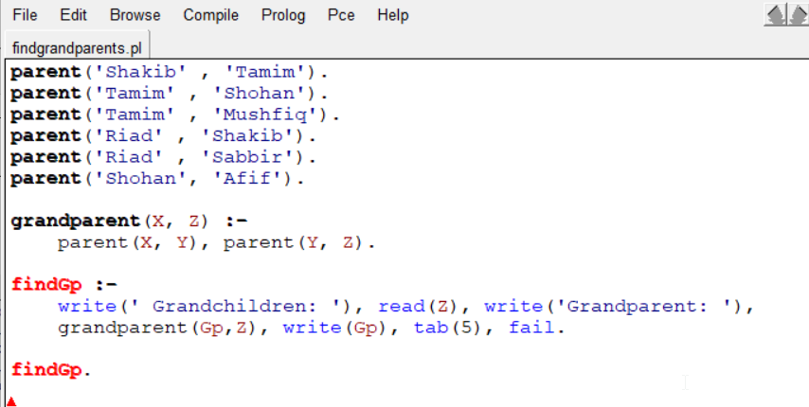

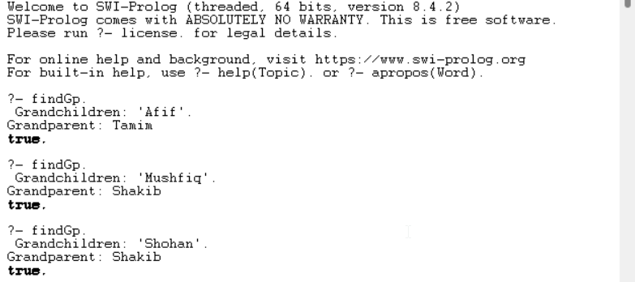

**Python Code:**

tupleList1=[('parent', 'Shakib' , 'Tamim'),

('parent', 'Tamim' , 'Shohan'),  
 ('parent', 'Tamim' , 'Mushfiq'),  
 ('parent', 'Riad' , 'Shakib'),  
 ('parent', 'Riad' , 'Sabbir'),  
 ('parent', 'Shohan', 'Afif')]

X=str(input("Grandchildren:"))  
print('Grandparent:', end=' ')  
i,j=0,0  
for i in range(6):  
 if ((tupleList1[i][0] == 'parent')&( tupleList1[i][2] == X)):  
 for j in range(6):  
 if ((tupleList1[j][0] == 'parent') & ( tupleList1[i][1] == tupleList1[j][2])):  
 print(tupleList1[j][1], end=' ')

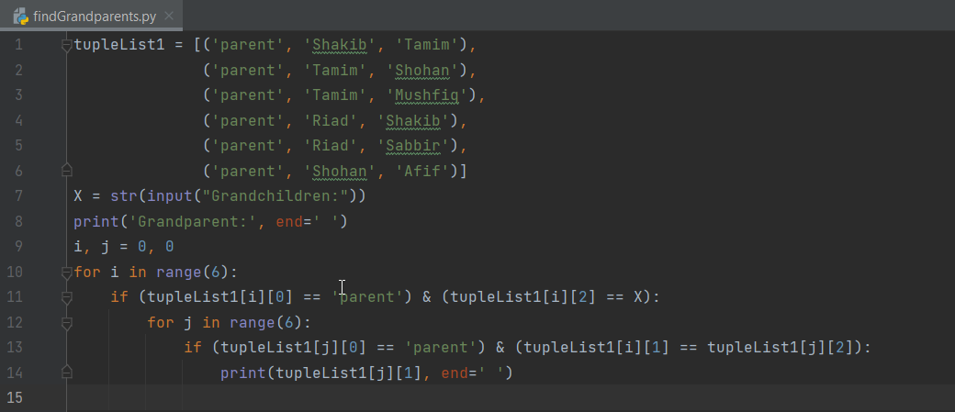

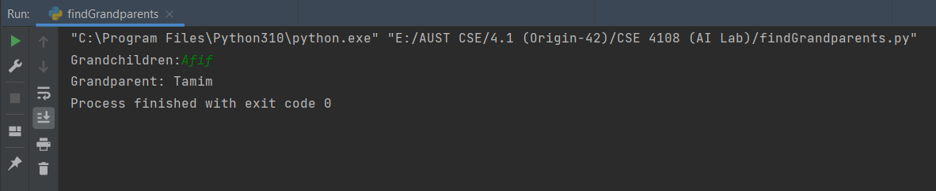

**Question 2**: Enrich the KB with ‘brother’, ‘sister’, ‘uncle’ and ‘aunt’ rules in Python and Prolog.

**Solution:**

**Prolog Code:**

male('Shakib').

male('Tamim').

male('Liton').

male('Shohan').

male('Afif').

female('Zenia').

female('Tanjin').

female('Ayesha').

parent('Shakib' , 'Tamim').

parent('Tamim' , 'Liton').

parent('Tamim' , 'Shohan').

parent('Tamim' , 'Ayesha').

parent('Afif' , 'Shakib').

parent('Shohan' , 'Zenia').

parent('Shohan' , 'Riad').

parent('Shohan' , 'Tanjin').

parent('Riad' , 'Mustafiz').

brother(Y, Z) :-

parent(X, Y), parent(X, Z), male(Y), not(Y=Z).

sister(Y, Z) :-

parent(X, Y), parent(X, Z), female(Y), not(Y=Z).

uncle(Y, U) :-

parent(X, Y), parent(X, Z), parent(Z,U), male(Y), not(Y=U), not(Y=Z).

aunt(Y, U) :-

parent(X, Y), parent(X, Z), parent(Z,U), female(Y), not(Y=U), not(Y=Z).

findBrother :-

write(' Siblings: '), read(Z), write('Brother: '),

brother(Brother,Z), write(Brother), tab(5),fail.

findBrother.

findSister :-

write(' Siblings: '), read(Z), write('Sister: '),

sister(Sister,Z), write(Sister), tab(5),fail.

findSister.

findUncle:-

write(' Niece/Nephew: '), read(Z), write('Uncle: '),

uncle(Uncle,Z), write(Uncle), tab(5),fail.

findUncle.

findAunt:-

write(' Niece/Nephew: '), read(Z), write('Aunt: '),

aunt(Aunt,Z), write(Aunt), tab(5),fail.

findAunt.

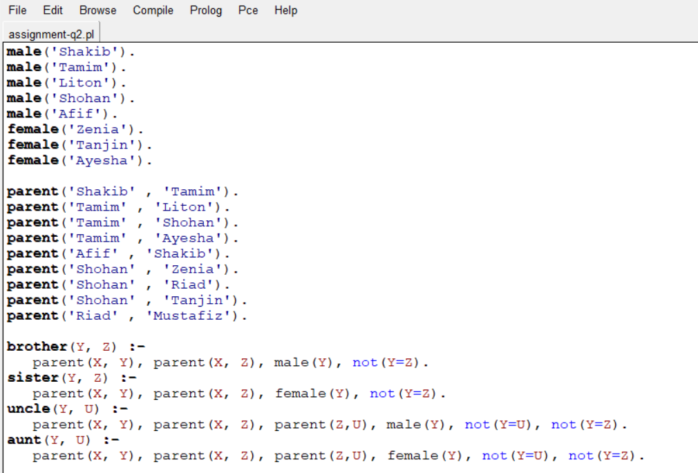

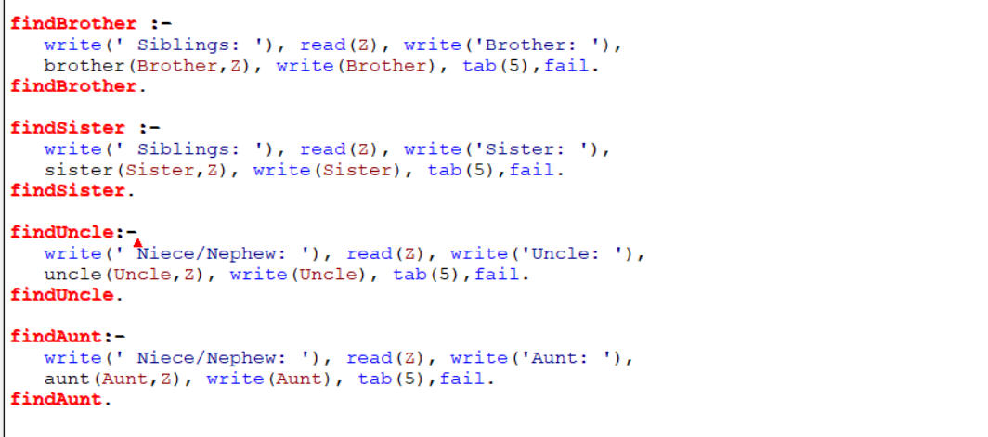

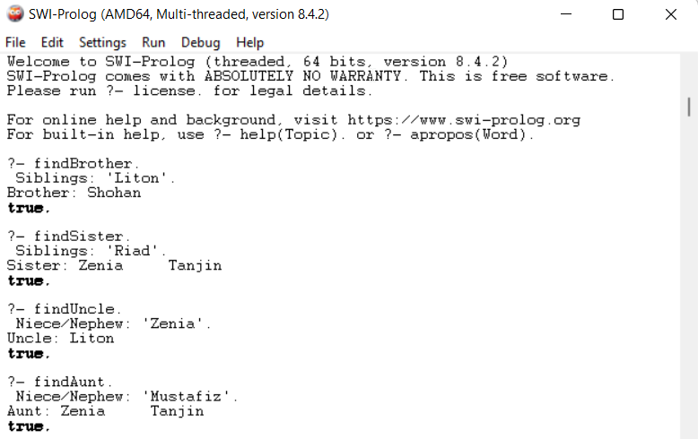

**Python Code:**

tupleList1=[('parent', 'Shakib', 'Tamim'),  
 ('parent', 'Tamim', 'Liton'),  
 ('parent', 'Tamim', 'Shohan'),  
 ('parent', 'Tamim', 'Ayesha'),  
 ('parent', 'Afif', 'Shakib'),  
 ('parent', 'Shohan', 'Zenia'),  
 ('parent', 'Shohan', 'Riad'),  
 ('parent', 'Shohan', 'Tanjin'),  
 ('parent', 'Riad', 'Mustafiz')]  
tupleList2=[('gender', 'Shakib', 'male'),  
 ('gender', 'Tamim', 'male'),  
 ('gender', 'Liton', 'male'),  
 ('gender', 'Shohan', 'male'),  
 ('gender', 'Ayesha', 'female'),  
 ('gender', 'Afif', 'male'),  
 ('gender', 'Zenia', 'female'),  
 ('gender', 'Riad', 'male'),  
 ('gender', 'Tanjin', 'female'),  
 ('gender', 'Mustafiz', 'male')]  
  
X=str(input("Sibling:"))  
print('Brother:', end=' ')  
i,j,k=0,0,0  
for i in range(9):  
 if ((tupleList1[i][0] == 'parent') & ( tupleList1[i][2] == X)):  
 for j in range(9):  
 if ((tupleList1[j][0] == 'parent') & ( tupleList1[i][1] == tupleList1[j][1]) & ( tupleList1[j][2] != tupleList1[i][2])) :  
 for k in range (10) :  
 if((tupleList1[j][2] == tupleList2[k][1]) & (tupleList2[k][2] == 'male')) :  
 print(tupleList1[j][2], end=' ')  
print("\n")  
X=str(input("Sibling:"))  
print('Sister:', end=' ')  
i,j,k=0,0,0  
for i in range(9):  
 if ((tupleList1[i][0] == 'parent') & ( tupleList1[i][2] == X)):  
 for j in range(9):  
 if ((tupleList1[j][0] == 'parent') & ( tupleList1[i][1] == tupleList1[j][1]) & ( tupleList1[j][2] != tupleList1[i][2])) :  
 for k in range (10) :  
 if((tupleList1[j][2]== tupleList2[k][1]) & (tupleList2[k][2] == 'female')) :  
 print(tupleList1[j][2], end=' ')  
print("\n")

X=str(input("Niece/Nephew:"))  
print('Uncle:', end=' ')  
i,j,k,l=0,0,0,0  
for i in range(9):  
 if ((tupleList1[i][0] == 'parent') & ( tupleList1[i][2] == X)):  
 for j in range(9):  
 if ((tupleList1[j][0] == 'parent') & ( tupleList1[i][1] == tupleList1[j][2]) & ( tupleList1[j][2] != tupleList1[i][2])) :  
 for k in range (9) :  
 if((tupleList1[j][0] == 'parent') & (tupleList1[j][1] == tupleList1[k][1]) & (tupleList1[i][1] != tupleList1[k][2])):  
 for l in range (10) :  
 if((tupleList1[k][2] == tupleList2[l][1]) & (tupleList2[l][2] == 'male')) :  
 print(tupleList1[k][2], end=' ')  
print("\n")

X=str(input("Niece/Nephew:"))  
print(Aunt:', end=' ')  
i,j,k,l=0,0,0,0  
for i in range(9):  
 if ((tupleList1[i][0] == 'parent') & ( tupleList1[i][2] == X)):  
 for j in range(9):  
 if ((tupleList1[j][0] == 'parent') & ( tupleList1[i][1] == tupleList1[j][2]) & ( tupleList1[j][2] != tupleList1[i][2])) :  
 for k in range (9) :  
 if((tupleList1[j][0] == 'parent') & (tupleList1[j][1] == tupleList1[k][1]) & (tupleList1[i][1] != tupleList1[k][2])):  
 for l in range (10) :  
 if((tupleList1[k][2] == tupleList2[l][1]) & (tupleList2[l][2] == 'female')) :  
 print(tupleList1[k][2], end=' ')  
print("\n")

